1/25/2021

Report on Internship

Streams Tech Ltd.

Report on Internship

Course Code: SE 701

**Submitted to**

Intern Place Office

Institute of Information Technology

University of Dhaka

**Submitted by**

Amran Hossain

BSSE 0917

Session: 2016-17





7th Semester, BSSE 09th Batch

Institute of Information Technology

University of Dhaka

Submission date: 25 January, 2021

Letter of Transmittal

January 25, 2021

The Chairman

BSSE 4th Year Exam Committee, 2020

Institute of Information Technology

University of Dhaka

Dear Sir,

It gives me immense pleasure to submit my report on Internship at Streams Tech Ltd. In this report, I have tried to describe my experience, project works, and achievements and so on. All the works presented here are done with utmost sincerely and honestly.

As part of my internship, I have served in Streamstech Ltd for six months where I have not only gained real life work experience but understood the process of the team work and its various aspects. This report includes a detail review of the office as well as the functionalities of the team. As a document of my effort during the internship periods I have conducted all the project works that I have done during my internship periods, specially their requirement, functionalities and technical specification.

I am so thankful to Institute of Information Technology for giving me the intern opportunity in a renowned software company. I am looking forward to your effective feedbacks on my entire report.

Sincerely yours,

Amran Hossain

BSSE 0917

7th Semester

Bachelor of Science in Software Engineering

Institute of Information Technology

University of Dhaka

Letter of Endorsement

To whom it may concern

Subject: Approval of the Report

This letter is to certify that, all the information mentioned in this document is true and not confidential to the company. The projects mentioned here have had successful involvement of Amran Hossain, (BSSE0917), Institute of Information Technology, and University of Dhaka.

I wish her all the best and hope that he will lead a successful career.

Shafiul Parvez Akash

Director of Information

Streams Tech Ltd

Contact: akash@stramstech.com

Acknowledgement

Firstly I am really thankful to Institute of Information technology and it’s Intern Program Office for arranging the wonderful internship program for me. I am also grateful to Streams Tech for recruiting me as an intern.

I take this chance to express my significant appreciation and profound respects to Shafiul Parvez, Project Manager and Maeenul Islam, Chief Technology Officer of Streamstech for their praiseworthy direction, observing and steady consolation during my entire internship.

I also would like to thank Dr. Md. Shariful Islam, Professor and Director of Institute of Information Technology, University of Dhaka for giving me the opportunity to take part in the internship such a renowned organization.

I also make this chance to express a profound sense for gratitude to Md. Habibur Rahman, Senior Software Engineer of Streams Tech and my supervisor for his friendly support, guidance.

I am likewise grateful to all my team members and individuals from Streams Tech for making my adventure smooth and noteworthy. Finally I would thank and tremendous gratitude to my team members including Fazlay Rabbi (Software Engineer Intern), Musa Ali(Software Engineer Intern), Mostafijur Rahman Monir (Senior Software Engineer), Md. Mekayel Anik (Software Engineer), Ragib Noor (Software Engineer), Nazmul Hasan (Software Engineer), Shahnewaz Rasel (Development Manager & MSBI consultant), Farhan Abdullah (Software Quality Assurance Engineer), Shorif Hossain Khan (Senior Graphic Designer), Tonmoy Bhowmik (Software Engineer) for giving me an effective period of experience.

Executive Summery

This document deals with the author experiences and contributions towards the Streams Tech as an intern. It also represents the achievements and challenges during the internship program. The scope of this document is to identify and describe the analysis carried out, projects completed, experience gained and focuses on the achievements as an intern.

The Internship Program Office of Institute of Information Technology (IIT) the University of Dhaka offers their bachelor’s student to take an internship during their 7th semester. The goal of offering and taking this internship is to provide students with the opportunity to get practical work experiences and applied software engineering practices in real life projects. It is a golden opportunity for the student to learn new things and getting familiar with the industry during their student life

Being a bachelor program student of IIT, I have joined Streams Tech as an intern. I was cordially welcomed by the Streams Tech family. However, after getting proper training, I started working as a Full Stack developer along with practicing various software engineering practices. I was treated as an employee and got all the facilities just like other employees. I have explored new technologies and practices, got familiar with industry people and faced new challenges. I feel really fortunate to have support and mentoring from all of my teammates and team leaders.

During my last six semesters, I have learned many software engineering practices. However, it all about to theoretical knowledge but in the internship, I found a practical implementation of that such as agile process of development, scrum, sprint etc. It really helps me to make the link between my theoretical knowledges with the practical implementations.

The experience of working the project help me both develop my problem-solving skills and practicing the software engineering best practices. This internship program helps me to improve my skills, confidence and provide me an opportunity to be a professional Software Engineer.

Table of Contents

Contents

1.1 Preface 1

1.2 Origin of the Report 1

1.3 Objectives 2

1.3.1 Broad Objective 2

1.3.2 Specific Objective 2

1.4 Scope 2

1.5 Methodology 2

1.5.1 Primary data 3

1.5.2 Secondary data 3

1.6 Limitation 3

2.1 overview 4

2.2 Vision and Mission 4

2.3 Environment and Culture 4

2.3.1 Location 5

2.3.2 Arrangement 5

2.3.3 Conference Room and Meeting Room 5

2.3.4 Dress Code 5

2.3.5 Office Schedule 5

2.3.6 Prayer Room 5

2.3.7 Dining 6

2.3.8 Birthday Celebration 6

2.3.9 Relationship between employees 6

2.3.10 Personal Event Celebration 6

2.3.11 Monthly Staff Meeting and CTO Meeting 6

2.3.12 Pitha festive 7

2.3.13 Yearly Tour 7

2.3.14 Medical Services 8

2.3.15 Working Environment 9

2.3.16 Streams talk 9

2.4 Services 9

2.4.1 Advanced GIS Solution 9

2.4.2 Mobile Application Development 9

2.4.3 Dashboard 9

2.4.4 Web Application development 10

2.4.5 Desktop Application Development 10

2.4.6 Data Integration, Processing, Analysis and Visualization 10

2.4.7 Water Modeling and Consultancy Services 10

2.5 Technologies and tools 10

2.6 Products 11

2.6.1 Trace 11

2.6.2 GeoSWMM 12

2.6.3 QStats 12

2.6.4 SurfGIS 13

2.6.5 Hourpad 13

2.6.6 ILoydList 13

2.6.7 Adopt a hydrant 13

2.6.8 Stylepad 14

2.6.9 WaterNam 14

2.7 Clients 14

3.1 Overview 15

3.2 Facilities For intern 15

3.3 Assignment of work 16

3.4 Evaluation of interns 16

3.5 conclusion 16

4.1 Overview 17

4.2 Project involvement 17

4.3 Project-1 (Stl_Showcase) 17

4.4 Project-2 (Jantrik Crud) 23

4.5 Project-3(Buet88_club) 23

5.1 Overview 31

5.2 Working Period 31

5.3 My Contribution 31

5.4 Challenges 32

6.1 Overview 33

6.2 Professional growth 33

6.2.1 How to communicate 33

6.2.2 Stop fingering points 33

6.2.3 Punctuality 34

6.2.4 Appraisal of Work 34

6.2.5 Co-operative 34

6.3 Technological growth 34

6.3.1 Tools and IDE 34

6.3.1.1 Visual Studio 2017 34

6.3.1.2 Visual studio Code 34

6.3.1.3 JetBrains ReSharper 35

6.3.1.4 Microsoft SQL Server Management Studio 2017 35

6.3.1.5 PostgreSQL 35

6.3.1.6 Postman 35

6.3.1.7 SourceTree 36

6.3.2 Language and Framework 36

6.3.2.1 Language 36

6.3.2.2 Framework 37

6.4 Self-Assessment 38

6.4.1 Attitude As an intern 39

6.4.2 Ability to Learn In Streams Tech 39

6.4.3 Dependability 39

6.4.4 Quality of Work 39

6.4.5 Relationship with colleagues 40

6.4.6 Maturity Poise 40

6.4.7 Judgment 40

6.4.8 Overall Performance 40

List of figures

Figure 1: Pitha festive 7

Figure 2 : Saint Martin 8

Figure 3: Saint Martin intern with Streams Tech employee. 8

Figure 4: Services 9

Figure 5: Streams Tech Technologies. 11

Figure 6: Streams Tech Client 14

Figure 7: About page of STl_Showcase 18

Figure 8: M&E page for STL_SHowcase 18

Figure 9: Web app part in stl_showcase 19

Figure 10: BI part in stl_showcase 19

Figure 11: Technology part in stl_showcase 20

Figure 12: Contact page of stl_showcase 20

Figure 13: Mobile App part for stl_showcase 21

Figure 14: Admin in stl_showcase 21

Figure 15: Admin part of Technology stack 22

Figure 16: GIS in stl_showcase 22

Figure 17: Home page of buet88 24

Figure 18:buet88 login page 24

Figure 19: adding hall in admin panel 25

Figure 20: Table List in admin panel 25

Figure 21: Table List in admin panel 26

Figure 22: Member list 26

Figure 23: add member Form 27

Figure 24: add member form 27

Figure 25: add children 28

Figure 26: family photo upload 28

Figure 27: send message 29

Figure 28: Member information 29

Figure 29: Event Show 30

Figure 30: Authentication part 30

Chapter 1: Introduction

# Preface

Internship is a beneficial procedure for students to link-up their academic experience with industry practices. It gives students an opportunity to sharpen their skills, gain expertise through work on advanced productions and be familiar with arduous real-world environment. Internship also provides any academic institution an opportunity to get up-to-date with new industry trend. As well as, industries get opportunity from Internship program to earn the idea about the research and development fields of the academia. In a word, internship establishes relation between academic institutions and industries. Institute of Information Technology (IIT) of Dhaka University provides a wonderful opportunity to students to experience a six-month internship within their academic curriculum. For having an internship during bachelor program IIT always give emphasis on both academic study and industry practices to keep up-to-date and cope up with new technologies. IIT devoted to make world class software engineer. A variety of technically specialized courses is conducted by industry professionals to accomplish its objective. Occasionally industry people are also invited to host seminars and workshop to talk about their culture and practices with students. Offering 6th month internship in 7th semester IIT broaden students’ mission to work in world class organization and provides a practical knowledge of software industry. I feel proud of being a student of Institute of Information Technology, University of Dhaka because it provides this worthy opportunity to me within the bachelor program. Streams Tech Ltd.is one of the leading software company in Bangladesh, cordially accepted me as an intern and gave me chance to utilize my theoretical knowledge in real world environment. I joined Streams Tech as an intern 5th January, 2020 and end 30th June. This report covers my learning and experience during intern time. Being a student of IIT, after completing my 6th semester successfully I was offered to take the internship program at Streams Tech. I tried my level best to gain knowledge of the industrial culture and practices so that I may apply this gained knowledge and experience in my upcoming academic courses and career.

# Origin of the Report

As a part of my bachelor program evaluation, I was instructed to submit a report on internship program experience. The report is intended to represent the overview of Streams Tech environment as well as my professional growth and project involvements there. It describes the scope of potential learning for students at industrial environment. It can also provide an overall experience feedback to upcoming batches who would like to do internship at Streams Tech. It can help them to build their selves according to industry norms.

# Objectives

This report is prepared to deliver its reader facts and insights about these following objectives:

## 1.3.1 Broad Objective

To describe the internship program experience gained in my internship period.

## 1.3.2 Specific Objective

✓ To describe the working environment and culture of Streams Tech Ltd.

✓ To present the services (type of projects) provided by Streams Tech

✓ To describe the facilities provided by Streams Tech to their employee

✓ To mention the industrial practices, I have learnt in my internship period

✓ To highlight the technologies and the software development process adopted by Streams Tech

✓ To describe the real-life projects, I involved

✓ To represent my acquired skill in my internship period

# Scope

This report deals with my experiences and knowledge’s that I have earned through the internship program. The company profile of Streams Tech and its culture are also briefly discussed here. How a team works and the process of working as a team along with my role, being a part of successful team, experiences within a team are also summarized in this report. How I have adapted myself with the company culture and technologies is also mentioned. Especially through this report I try to reflect on my project involvements and my experience of working in real-life projects. The report concludes by elaborating my technical and professional growth after experiencing the internship program.

* 1. Methodology

I have presented different kinds of information in this report which I gathered during internship period and collected from any written document such as Internet or from another person. Most of the information is collected from web sites, articles, Streams Tech employees and some journals. Information included in this report are classified into two categories, primary data source and secondary date source.

## Primary data

➢ Experience gathered from internship

➢ Collaboration with colleagues and team mates during work

➢ Seminars to discuss current streams talk

## Secondary data

➢ Streams Tech official website

➢ Linked in page of Streams Tech

➢ Website of Streams Tech client

➢ Also, some tutorial website

# Limitation

As company policy is highly sensitive about sharing internal information outside of the company, here minimal information is provided with respect to company policies and taking permission from the authority. Working almost 6th month in SELISE I have involved so many activates and learn many technologies. But I was assigned in a project and most of my intern period I have dedicatedly worked on my project. So, it is difficult to give an appropriate overview of other projects development process. Provided information about others project is based on my experience and sharing knowledge with my colleagues. In this short report it is not possible to give a comprehensive and clear picture of the company profile. So, the report information is limited to respect rules and regulation of company.

Chapter 2 Company’s profile

# 2.1 overview

Streams Tech Ltd. is a software development company providing full-cycle software engineering, custom application development and system integration services. Our business goal is to help our clients meet their software development needs on time and within a budget, while exceeding quality requirements. Streams Tech Ltd. project managers plan, execute and monitor projects from initiation to closing to ensure each project is a success. We specialize in the development of .Net application, customized ArcGIS based geographic information system (GIS) software, SharePoint and data integration, processing, analysis and visualization systems. We are also very open to expanding our capabilities depending on your needs. We have successfully conceptualized, designed and developed complete software as well as customized products to suit our clients' needs and we will do the same for you. Please contact us with any queries.

Streams Tech Ltd. engineers also perform environmental, water resources and GIS modeling using special software. Our software development capabilities enhance our ability to find efficient solutions to modeling and data processing. We are committed to your success in any engineering and manufacturing application. Streams Tech help with engineering, operations, and automation or modeling services.

# 2.2 Vision and Mission

“For Software, Solutions and Success” is the core mission and vision of this company. It’s mission to provide customers with services which are strongly based on intellectual capacity and with best technology of current world to fulfill all needs of its clients.

# 2.3 Environment and Culture

Man power is one of the most important resources of any organization. Performance and success of an organization depends on the employee of the company. Therefore, providing a healthy and friendly environment in addition with professional setup is very important. Streams Tech believe that in the journey employee should stay fit both physically and mentally while absolutely loving what they do.

## 2.3.1 Location

**US Office** **Bangladesh Office**

4031 University Drive, Suite 100 House No 16, Suite F4, Road No

Fairfax, Virginia 22030 23, Block B, Banani, Dhaka-1213

## 2.3.2 Arrangement

Since each employee working in a her/his own room, all member’s sitting placement are nicely arranged. As developers work for hours sitting on the same chair looking at their desktop, Streams Tech provide comfortable chairs which are adjustable to their height and arms.

## 2.3.3 Conference Room and Meeting Room

In Streams Tech there are one conference room for training the Streams Tech employee and meeting with clients from the outside of the company. There is also a meeting room for team where only the team use this room for their purpose.

## 2.3.4 Dress Code

There is no specific dress code in Streams Tech. Most of the employee comes with formal dress up.

## 2.3.5 Office Schedule

Time is flexible at Streams Tech. Employee can enter the office within 9a.m to 11 a.m. But getting into office after that will be counted as late. Office time is 9 am to 6 pm in regular, but in Ramadan it becomes 9 am to 4 pm. Monitoring time using Hour pad.

## 2.3.6 Prayer Room

There is a room where Streams Tech people can say prayer with Jamah. Regularly after Asar prayer read hadith in prayer room.

## 2.3.7 Dining

Streams Tech provide lunch to their employees. Each day varities item given in lunch. There are two kitchens. There are unlimited tea, coffee, biscuits. Also, two-time snack given by Streams Tech.

## 2.3.8 Birthday Celebration

Birthday of every employee is celebrated in Streams Tech Ltd. But if any employee does not want to celebrate his/her birthday because of religious belief, his/her birthday celebration is skipped.

## 2.3.9 Relationship between employees

Streams Tech Ltd. is like a family and every employee is a family member. There exists a strong family bond between employees. Here every good work is appreciated by the colleagues. Seniors often advise juniors about their careers.

## 2.3.10 Personal Event Celebration

Most of the employees celebrate their personal happy events at office. Because they believe Streams Tech Ltd. as a family and one should celebrate his/her happy moments with the family. Personal happy events like marriage, becoming parents or winning a great battle in table tennis.

## 2.3.11 Monthly Staff Meeting and CTO Meeting

In every month there held a staff meeting in the seminar room and it is called monthly staff meeting. Every employee must attend this meeting. Employees share their view about the company and the CEO of the company shares his view about the employees. Sometimes the CTO calls all the employees for meeting to discuss a particular topic and this kind of meeting is called “CTO Meeting”.

## 2.3.12 Pitha festive

Every year Streams Tech arrange pitha festive. We are happy that our first day was the pitha festive day and we enjoyed it nicely. Here is look

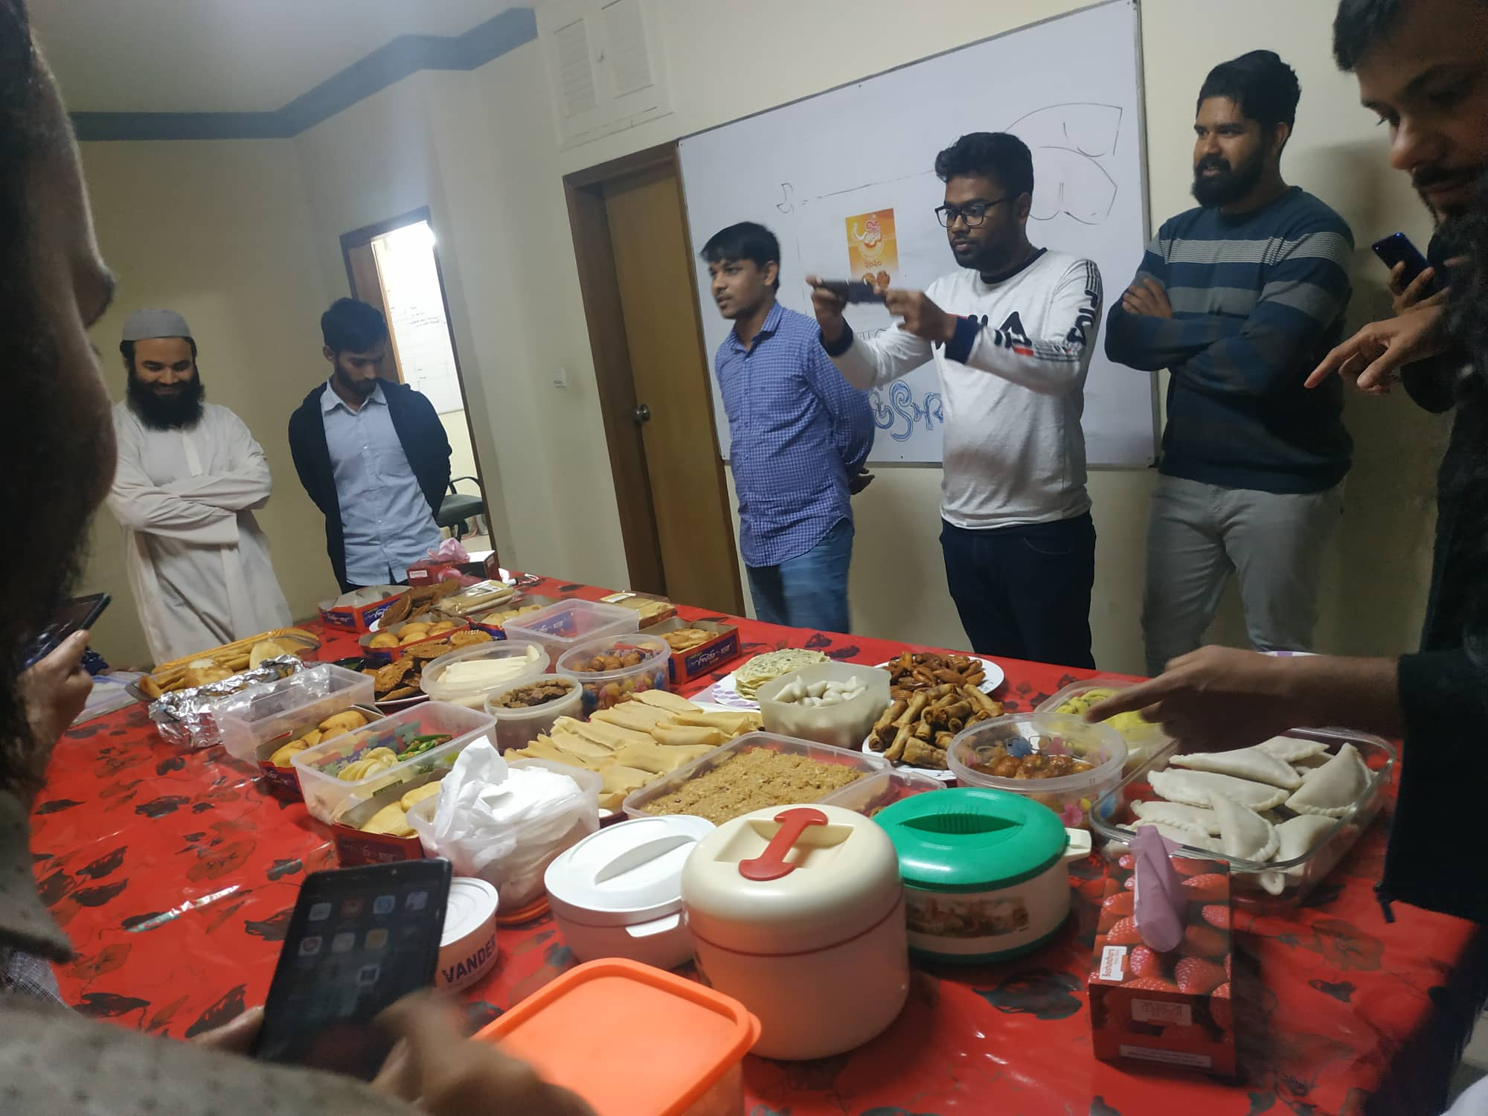

Figure 1: Pitha festive

## 2.3.13 Yearly Tour

Every year Streams Tech arrange picnic in a beautiful place. This year we went “Saint Martin Island”.

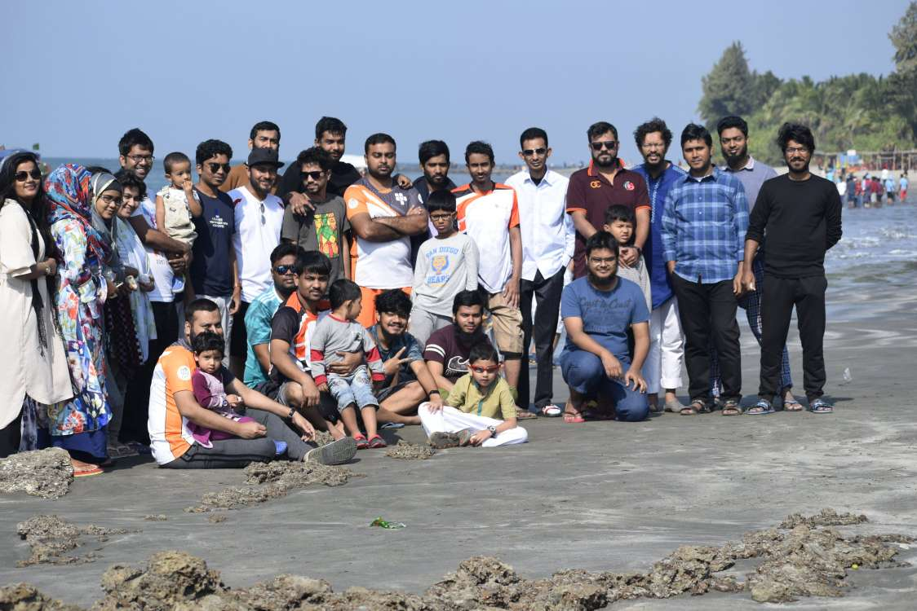

Figure 2 : Saint Martin

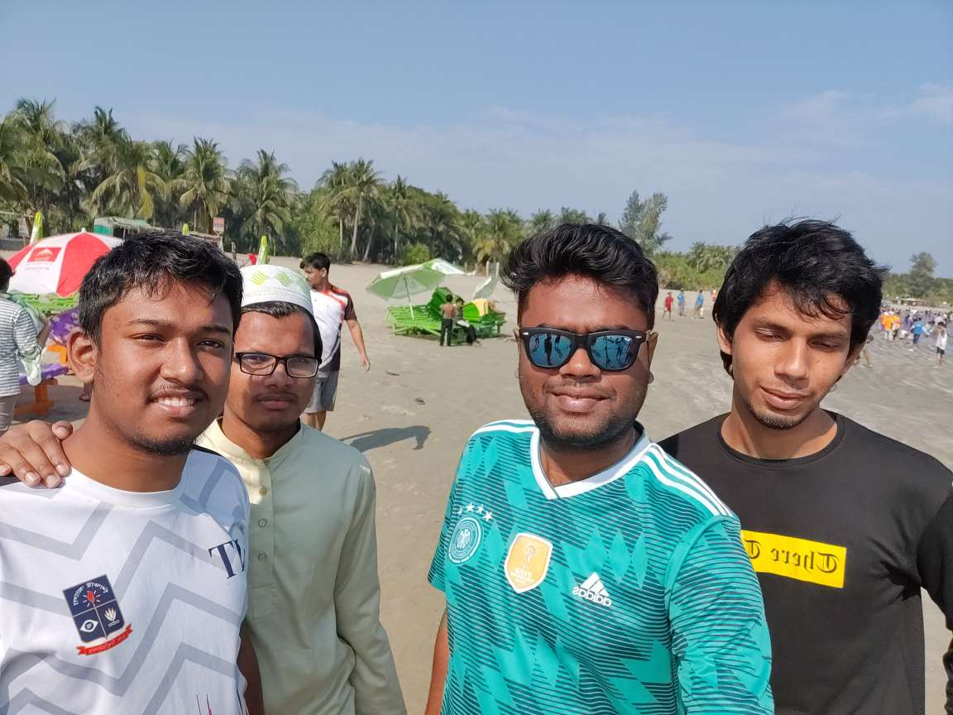

Figure 3: Saint Martin intern with Streams Tech employee.

## 2.3.14 Medical Services

Streams Tech Ltd. provides emergency medical services for the employees. There are also some basic needed medicines at office store like paracetamol, omeprazole tablets for gastritis.

## 2.3.15 Working Environment

Streams Tech Ltd. provides a friendly, flexible and nice working environment for the employees. The workspace is very well designed and well equipped with modern facilities. I joined there as an intern software engineer. I got the facilities that an experienced developer gets. So, there is no discrimination between an intern and a regular employee.

## 2.3.16 Streams talk

A session held in the company. Any of the employee inform another about new technology or resources by this session.

# 2.4 Services

Streams Tech provided Multiple Services. They are:



Figure 4: Services

## 2.4.1 Advanced GIS Solution

Streams Tech Ltd. provides GIS development and geo-data processing services. They develop custom modules for GIS platforms like ArcGIS that integrates GIS with modeling, significantly reducing time and effort needed for planning engineers.

## 2.4.2 Mobile Application Development

Streams Tech Ltd.’s mobile application developers have deep expertise creating apps for all the major platforms including IOS (iPhone, iPad), Android, BlackBerry and Windows Mobile. Mobile app designers and developers are creating some of the most innovative mobile application solutions on market today.

## 2.4.3 Dashboard

Streams Tech Ltd. Provide efficient, effective and user-friendly software solutions that allow client to meet their goals.

## 2.4.4 Web Application development

Engineers of Streams Tech Ltd. are specialized in developing various web applications. We have expertise in developing e-commerce solutions, CMS solutions, ERP solutions, dashboards and reporting and any kind of custom web solutions. We provide highly efficient and scalable web solutions and also provide continuous support for hosting, managing and improvements.

## 2.4.5 Desktop Application Development

Streams Tech Ltd. provides efficient, effective and user-friendly desktop application solutions that allow our clients to get best out of the products. It is expert in developing office management systems, workflow management systems, large systems involving client-server architecture, service-oriented systems and GIS based application for GIS data generation and manipulation and custom application based on clients need.

## 2.4.6 Data Integration, Processing, Analysis and Visualization

Streams Tech Ltd. has the expertise to transform your business data into information through data processing & extensive analysis. We have visualization tools both for web and desktop. You will have the facility to map/plot your GIS data on web. We have desktop applications for simulation your time series data sets.

## 2.4.7 Water Modeling and Consultancy Services

Streams Tech Ltd. provides water resources consulting services including data development and processing using geographic information system (GIS), and hydrologic, hydraulic and water quality modeling. We have dedicated environmental and water resources engineers who have extensive knowledge and experience in modeling. We strive to excel using the latest technologies and advanced modeling techniques that minimize cost and yet provide the best results

# 2.5 Technologies and tools

Streams Tech Ltd. utilize an array of technologies in order to develop their products with the best possible efficiency and optimized cost. Some of them technologies they use to develop these products are given bellow:

➢ NET Technologies- C#, ASP.NET, VB.NET, WPF, WCF, MVC, spring, .NET –core, .NET

➢ JAVA- J2EE, Spring, Hibernate

➢ Front-End- JavaScript, JQuery, LeafletJS, Google Maps API, Open Layer 3.0, Angular Js, Angular

➢ Microsoft SharePoint Development

➢ Databases- Microsoft SQL Server, POSTGRESQL, MYSQL, MS Access

➢ Business Intelligence- SSIS, SSRS, SSAS

➢ Mobile Application development- Android, Phone Gap

➢ PHP, JOOMLA, Code Igniter

➢ Microsoft SharePoint Development

➢ C, C++, Python, FORTRAN

➢ Mercurial

➢ Microsoft Project Extension Development

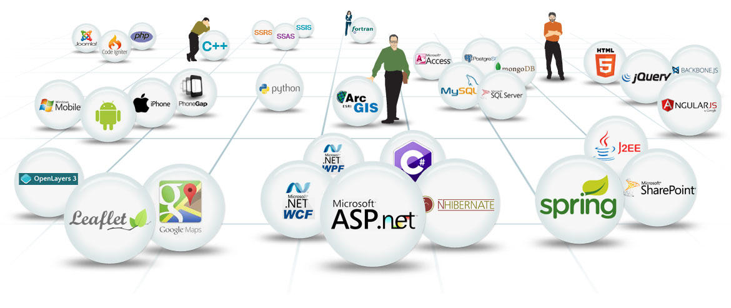

Figure 5: Streams Tech Technologies.

# 2.6 Products

Streams Tech Ltd. has developed several products. Description of them are given bellow:

## 2.6.1 Trace

Trace allows users to digitize graphs to capture numeric values from images, especially when the data that was used to generate a graph is unavailable. Trace can handle a large graph sliced into many images, both horizontally and vertically. The National Flood Insurance

Program (NFIP) of US Federal Emergency Management Agency (FEMA) studies flood prone areas along streams and shorelines and FEMA's Flood Insurance Study (FIS) reports include water surface elevation profiles for different recurrence intervals. In making changes to previously studied areas, is necessary to compare proposed water surface elevations with the effective elevations. For many old studies the effective water surface elevations are available only in hardcopies. Trace allows users to digitize water surface profiles from hardcopy graphs that span multiple sheets, making graph digitization for the re-delineation of flood plain boundaries, based on new topographic data, much less time consuming.

## 2.6.2 GeoSWMM

EPA's SWMM is a standalone urban water model which stores data in simple text files requiring users to preprocess and manually prepare model input data from Geographic Information System or CAD data files. Streams Tech, Inc. has developed GeoSWMM, a custom ArcGIS based data processing and management tool for EPA's SWMM, allowing users to set up and run the model without ever leaving the GIS environment. GeoSWMM allows users to efficiently manage and prepare input data and minimize the potential for data errors. Integrity of the model is ensured through automatic validation of data and by storing the data in a database environment. GeoSWMM is 100% compatible with EPA's SWMM Version 5 and the user interface is identical to EPA's SWMM. GeoSWMM eliminates the steep learning curve associated with custom model interfaces and yet gives users access to the full power of ArcGIS. GeoSWMM significantly cuts the time and effort required to develop a storm water or wastewater collection system model, increases the life of the model by storing the GIS data and model input in a single relational database and reduces the long-term maintenance cost of the model.

## 2.6.3 QStats

QStats performs statistical flood-frequency analyses of annual-maximum peak flows (annual peaks) following procedures recommended in Bulletin 17B of the Interagency Advisory Committee on Water Data (1982), referred to hereinafter as Bulletin 17B. The following sections document the implementation of the Bulletin 17B guidelines in QStats. This information is intended to assist the user with selection of program options and interpretation of the program output. Program users should refer to Bulletin 17B for the complete and definitive description of the recommended procedures. The Bulletin 17B procedures treat the occurrence of flooding at a site as a sequence of annual random events or trials. The magnitudes of the annual events are assumed to be independent random variables following a log-Pearson Type III probability distribution; that is, the logarithms of the annual peak flows are assumed to follow a Pearson Type III distribution. This distribution defines the probability that any single annual peak will exceed a specified stream flow. Given this annual exceedance probability, other probabilities, such as the probability that a future design period will be free of exceedances, can be calculated by standard methods, as described in Appendix 10 of Bulletin 17B. Program QStats estimates the parameters of the log-Pearson Type III frequency distribution from the logarithmic sample moments (mean, standard deviation, and

coefficient of skewness) of the record of annual flows, with adjustments for low outliers, high outliers, historic peaks, and generalized peak skew. The parameter values are used to calculate the percentage points (or quantiles) of the log-Pearson Type III distribution for selected exceedance probabilities.

## 2.6.4 SurfGIS

Many issues in our personal and professional lives have spatial contexts that require maps to visualize and communicate data. SurfGIS is a Geographic Information Systems (GIS) software which allows users to easily create, edit, view and share mapping data. This GPS-enabled web application provides access to maps online from field locations as well as from office environments through an internet browser on computers or mobile devices. No software installation is required. Creating and editing GIS data in SurfGIS is as simple as drawing points and lines on Google Maps and adding attributes on-screen. Additionally, GPS devices may be used to capture points, allowing users to create their own data. Readily available GIS data obtained from private, educational, non-profit, and government institutions can be uploaded to SurfGIS and integrated with a user's own data and Google Maps to create meaningful maps. The data can be downloaded in ready to use, standard GIS format for use with any other GIS software or to share with other users. SurfGIS can be used to inexpensively and efficiently develop GIS data of physical objects on the ground, including agricultural fields, buildings, trees, trails, manholes, and transit and utility structures, to name a few.

## 2.6.5 Hourpad

Time tracking is an essential component of any business. HourPad makes time tracking straightforward and simple. HourPad is easy to use and there are no limits to the number of clients and projects that you can add to the timesheet. It's also secure and safe, and can be hosted at your company internally. Tracking tasks and projects is even easier with HourPad's reporting.

## 2.6.6 ILoydList

ILoydsList is a mobile based buying & selling application that allows location-based product searching. It uses GIS based intelligence to suggest items that are available within the user’s preferred distance settings. Users can maintain their product list that they want to sell. Users choosing an item, user can communicate with the seller and finalize the purchase.

## 2.6.7 Adopt a hydrant

The Adopt Hydrant is map-based web app that gives citizens access to check and clear hydrants in their neighborhoods during the winter season and making it easier to fire workers to save time, cause and damage during urgent fire-related events. Co-operation from

community members are very helpful in lessening damage during winter fire hazards. Finding the fire hydrant buried below snow and then clearing it entail a considerable amount of time, which can prove dangerous in terms of delays caused in extinguishing fires and saving life and property.

## 2.6.8 Stylepad

 Survey application for handheld devices that runs on Android, IOS and Windows 8. Using this application, field surveyors can perform offline field surveys. There is a web-based administration panel that allows administrators to create questionnaire for the survey. The type of the questions allows custom branch conditions based on some answers, multilevel grouping in questions, repetition of some questions and more. The questionnaire set by the administrator can then be downloaded in the mobile device and survey can be performed without any further communication with the server. Survey can be performed as many times as required and after completing the surveys, the data can be sent to the central server. While doing the survey, any number of images can be captured with every question, custom comment can be added, free hand sketch can be drawn and GPS location can be captured for GIS based analysis. The application allows generation of summary report based on the collected data.

## 2.6.9 WaterNam

WaterNAM is a geospatial hydraulic model developed by the Streams Tech Ltd. for analysis and design of water distribution systems.  It performs both steady state and extended period simulation of water flow and quality, including constituent concentrations and fire-flow analyses, and energy-cost assessment.

# 2.7 Clients

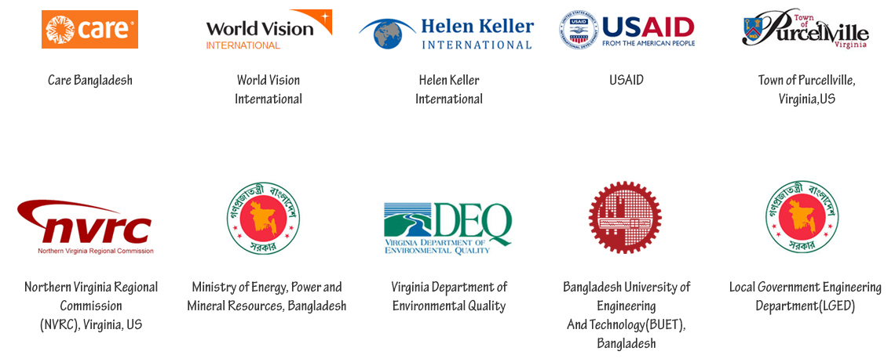 Figure 6: Streams Tech Client

Chapter 3 Internship at Streams Tech

# 3.1 Overview

Internship is an opportunity to familiar with own job field and to get a knowledge how real-life industry works are running before ending graduation. It very important to gathering practical knowledge, especially for technological students. It works like a bridge between the software industry and the students. It is a way for both the company and the student to promote each other where student represents their talent and capabilities and industry represents their culture, working environment and technology. As a student of Bachelor of Science of Software Engineering (BSSE) this year I got the opportunity to be an intern at Streams Tech. I am so delighted to be a part of Streams Tech in my internship.

Internship provides bigger scope to learn and gather knowledge which ultimately broaden one’s vision and ability to dream big to work one of the top industries of software engineering. This internship experience helps me not only to practice my theoretical knowledge and sharing my ideas but also make me conscious of different perspective of software industries of Bangladesh and has given me encourage to work for the best software industries in world.

# 3.2 Facilities For intern

From the first day, Streams Tech family welcomed us just like any new employee. We were introduced to the other members of Streams Tech family by the human resource manager of Streams Tech. We are treated as any other employee of Streams Tech. It never makes us feel that we are the intern here rather than an employee. From the beginning, we are taken care by our CTO and our supervisor. They spent their valuable time to make us comfortable and adaptable to the new environment and technologies.

• Dedicated workspace like any other employee

• Individual PC and other facilities

• Become a member of real-life project team

• Flexible working time and environment

• Leave for academic activities

• Healthy amount of remuneration

• Small sessions on new topic from CTO

• Opportunity to work in real life project

# 3.3 Assignment of work

In most of the cases, the company treated intern as immature resources. Besides, they are not assigned to real work. However, Streams Tech not only gave us the opportunity to work in real life projects but also allow us to share our personal opinions and approach to finding out the solution of a problem. If our approach is considered appropriate to them, it is cordially accepted and they implement it into their project. This also gives us inspirations and motivations to keep that practice.

# 3.4 Evaluation of interns

Every learning program should be ended up with the evaluation process. To evaluate our intern period an evaluation form is delivered to Streams Tech. My Supervisor, CTO decide how my intern was and evaluate me based on that. The feedback of this evaluation is really essential for me to improve myself and overcome my weakness for my future career.

# 3.5 conclusion

My internship is almost in conclusion since I have just passed almost five months of my internship. It was an awesome journey to be a part of Streams Tech. I just really love and appreciate the facilities provided for us at Streams Tech. I am thankful to IIT and Streams Tech for paving the way for me to take my internship at Streams Tech and completing this internship successfully.

Chapter 4 Project Involvement

# 4.1 Overview

In Institute of Information Technology, we have learned theoretical knowledge of many subjects. We have completed different courses on different technologies and different domain of Software engineering. Some important courses were object-oriented programing, web technology, software requirement specification, software testing, analysis and design. To gather experience with actual implementation of knowledge we were send to internship in renowned company. As internship is a part of our academic curriculum it plays an important role learning and schooling phase of a student. I have no prior knowledge how an internship will go. After assigned in Streams Tech I was pleased that in Streams Tech employees are accustomed with up-to-date technologies. Joining in Streams Tech I have gotten the opportunity to take part in Streams Tech family to learn new technologies. There I have done many assignments. Besides I have worked on different technologies to maintain the learning curve. Below I discussed some projects done by me and learning from Streams Tech.

# 4.2 Project involvement

After being assigned to a project I could really understand the difference between an academic project and a real-life industrial project. Streams Tech follow agile process in software development. So, as a beginner, I had to face the challenge of writing manageable code and of course within the deadline. But before being thrown into the deep ocean of real-life software project development, we went through a series of test projects, as part of training which mimicked practical software projects. In the following sections I am going to describe all of my projects in detail.

# 4.3 Project-1 (Stl_Showcase)

**Overview:** It is a web-based project. This project shows only all the project developed by Streams Tech. It is an internal project of Streams Tech. Here contact us page uses token-based authentication.

**Mentor**: Shafiul Parvez Akash

**Technologies:** ASP.NET MVC, MSSQL, ANGULAR, BOOTSTRAP, WEB API, Entity Framework

**Tools:** Visual Studio, Visual Studio Code, Microsoft SQL Server, Postman

**Period:** 25 January, 2020-20 February, 2020

Some screenshot of project:

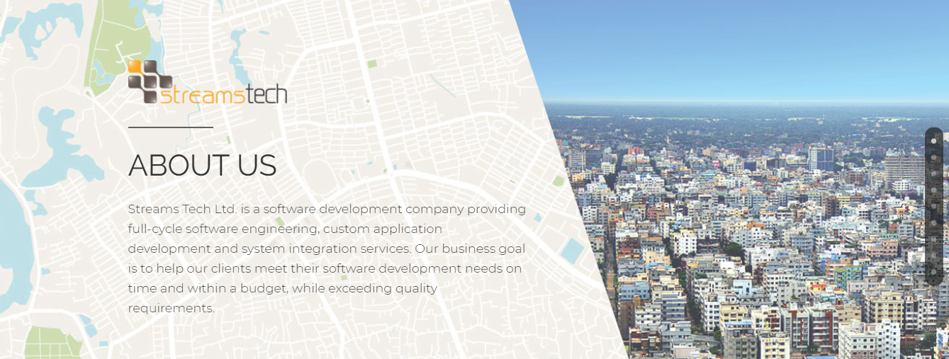

Figure 7: About page of STl_Showcase

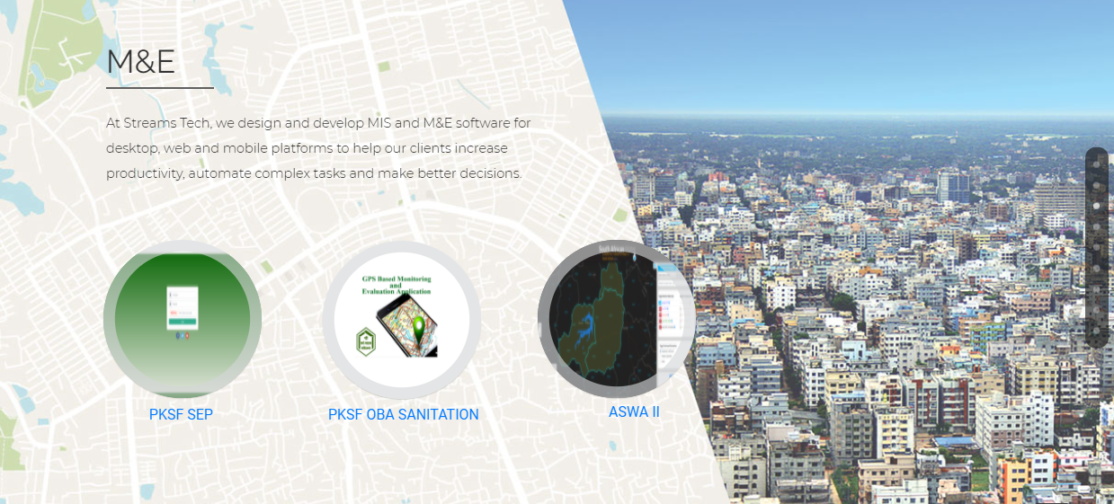

Figure 8: M&E page for STL_SHowcase

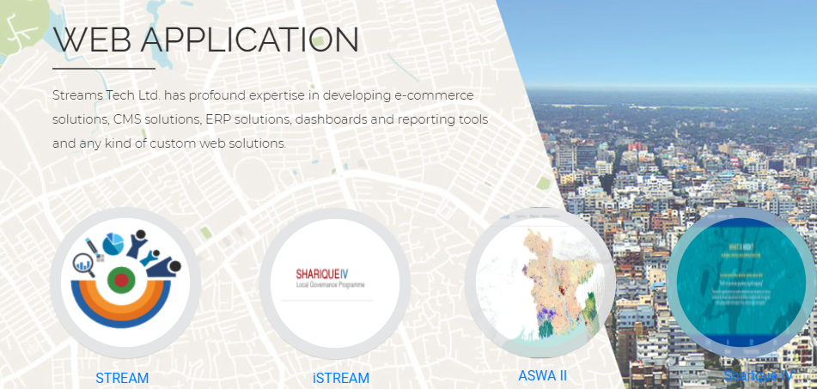

Figure 9: Web app part in stl_showcase

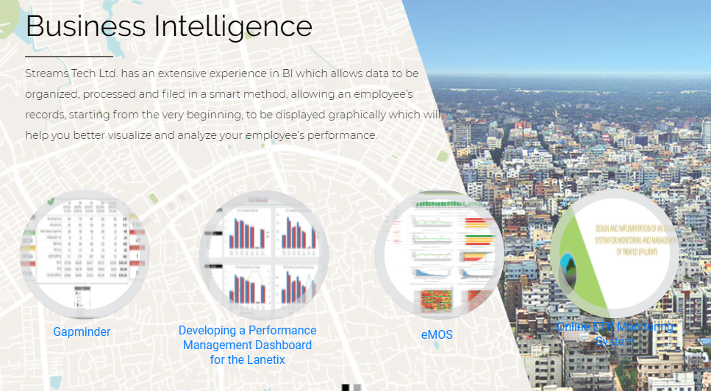

Figure 10: BI part in stl_showcase

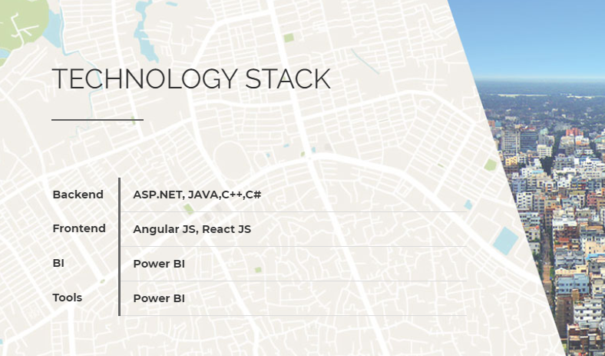

Figure 11: Technology part in stl_showcase

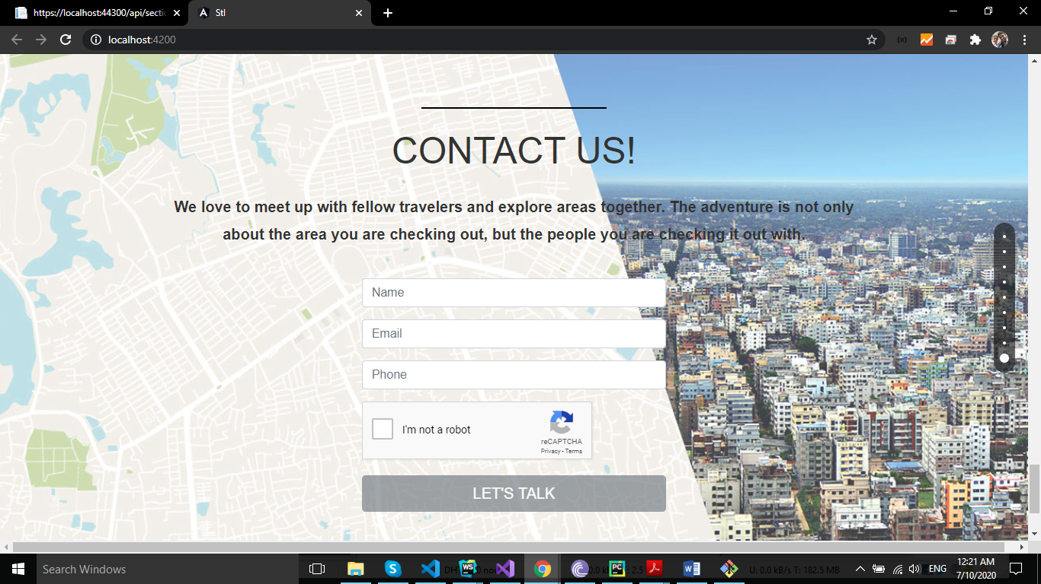

Figure 12: Contact page of stl_showcase

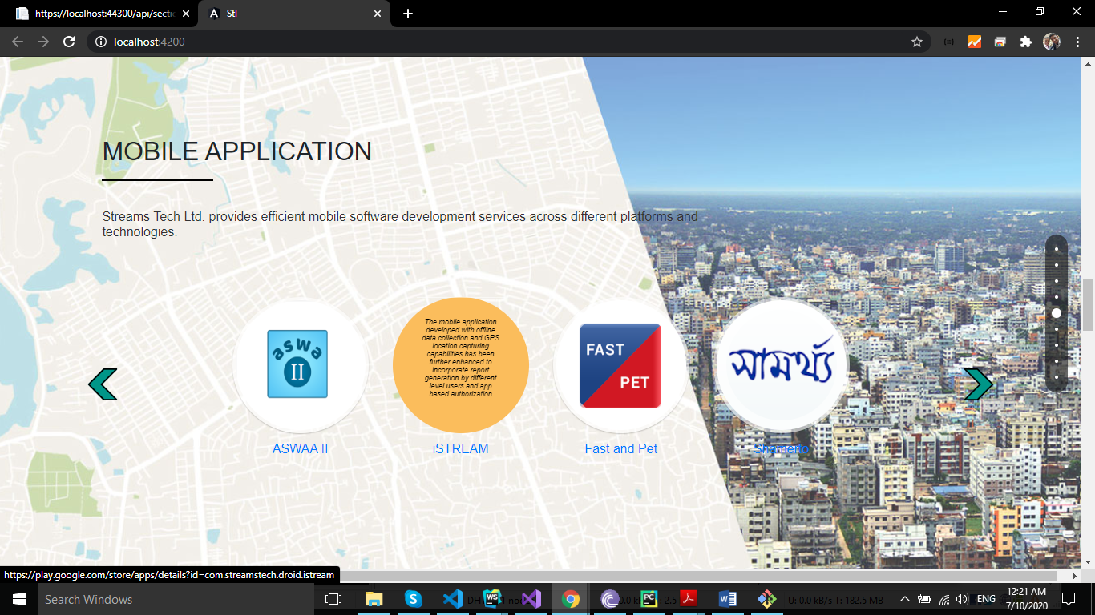

Figure 13: Mobile App part for stl_showcase

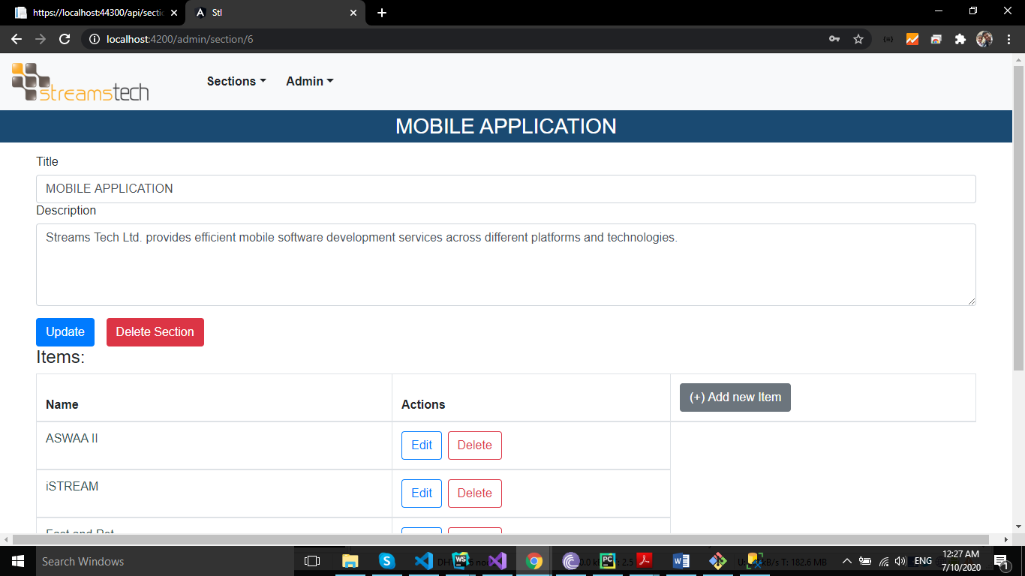

Figure 14: Admin in stl_showcase

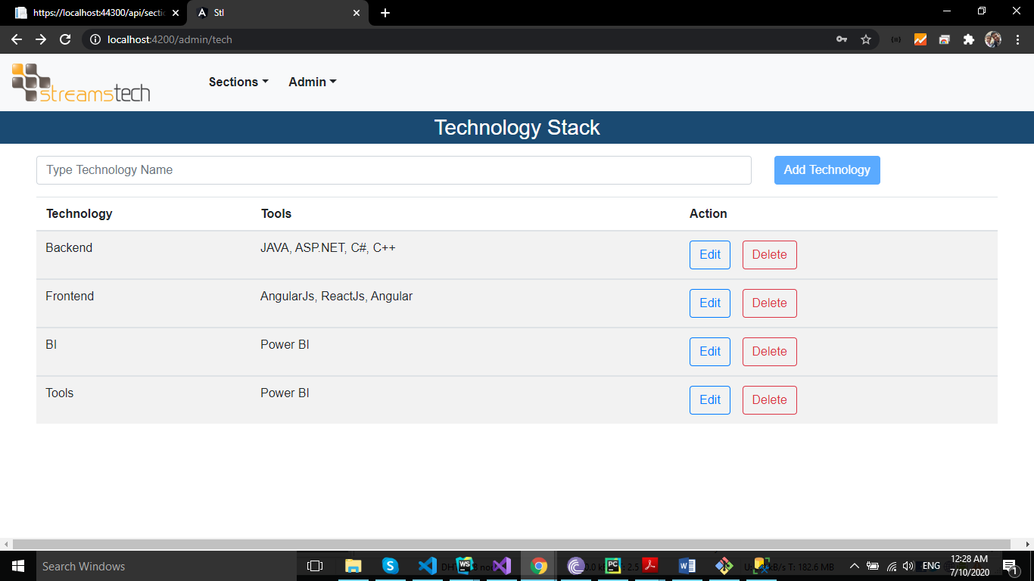

Figure 15: Admin part of Technology stack

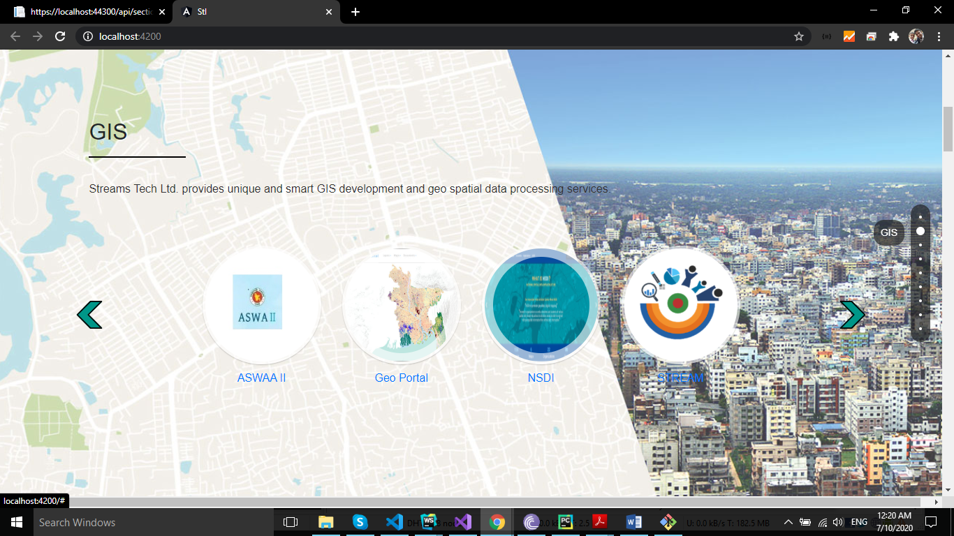

Figure 16: GIS in stl_showcase

# 

# 4.4 Project-2 (Jantrik Crud)

**Overview:** It is an internal project. It does like create, read, update, delete. It was developed in Angular JS. We tried to convert it to Angular. I have done this table convert into material table

**Mentor:** Maeenul Islam

**Technologies:** Angular

**Period:** 24 February, 2020 – 31 March, 2020

# 4.5 Project-3(Buet88_club)

**Overview:** This project owned by Buet. There are personal and family information and their social activities and publications for Buett88 batch. Frontend has two parts. Front parts and others admin panel. Admin panel is restricted. Only Admin members can access it. There are many lists of tables for members, users, events, halls, departments and publications. All of these features can add, edit, delete by authorized members who are admin. Front part shown only the publication, member, events, and users. User can edit his profile.

**Mentors**: Maeenul Islam and Shahnawaz Rasel

**Technologies:** Angular, ASP.NET core, Angular material, MDB bootstrap, Entity Framework.

**Tools:** Visual Studio, Visual Studio Code, Microsoft SQL Server, Postman

**Period:** 6 April, 2020 – 30 June, 2020

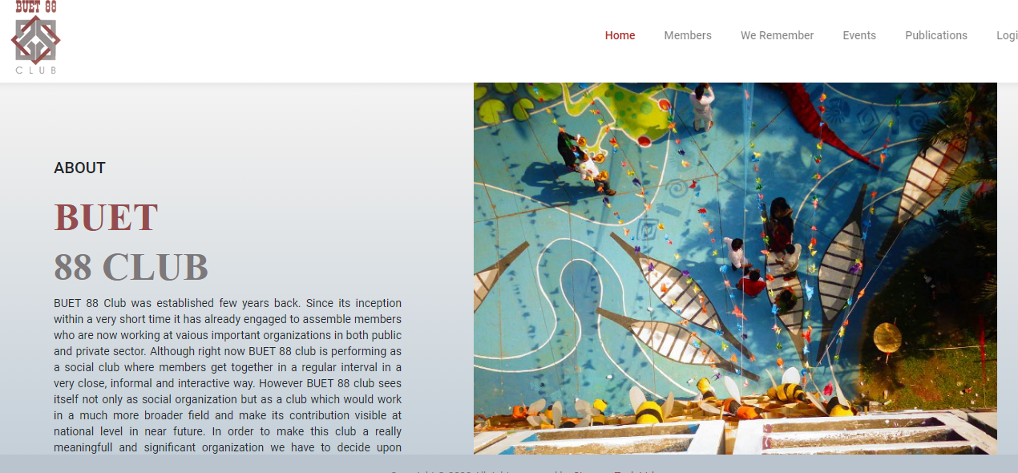

Figure 17: Home page of buet88

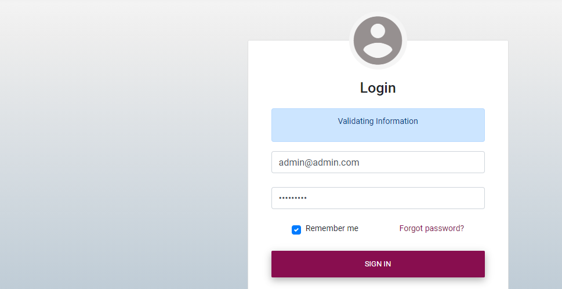

Figure 18:buet88 login page

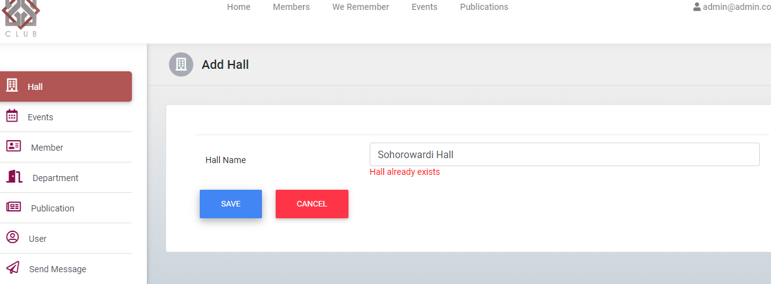

Figure 19: adding hall in admin panel

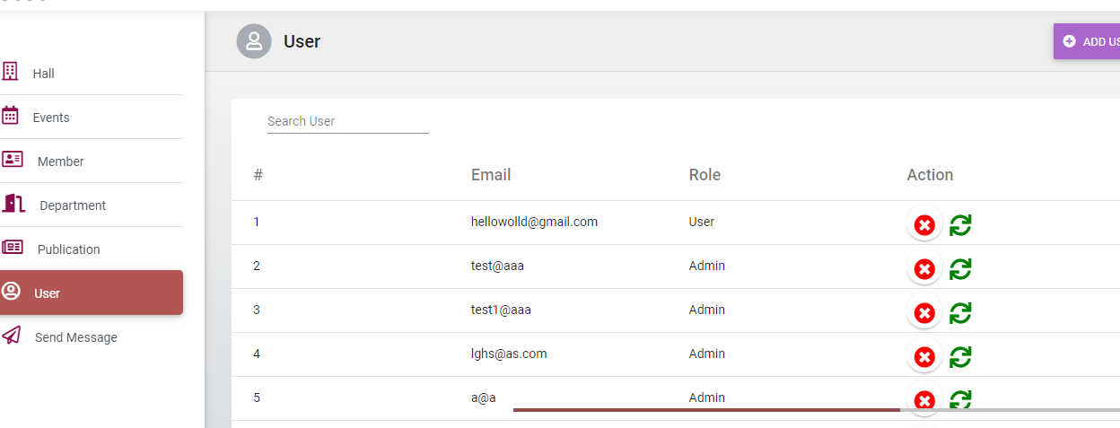

Figure 20: Table List in admin panel

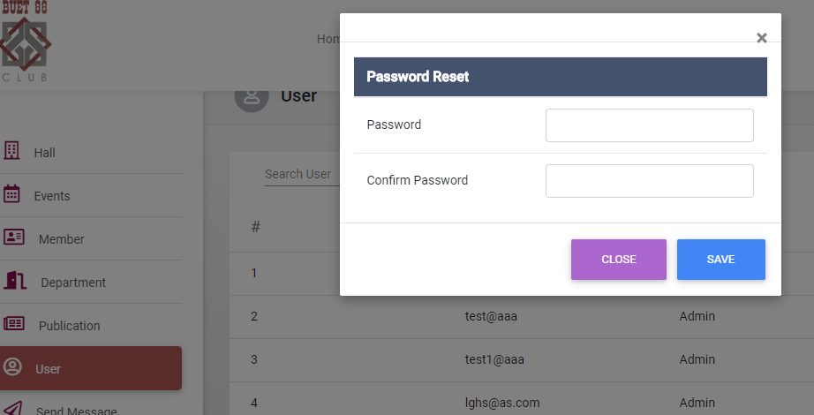

Figure 21: Table List in admin panel

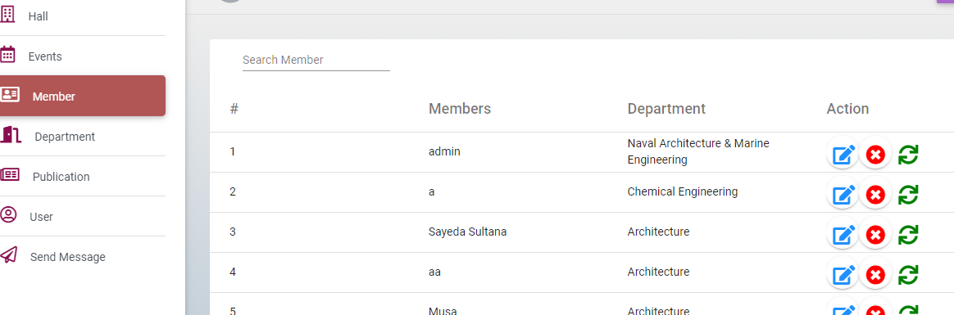

Figure 22: Member list

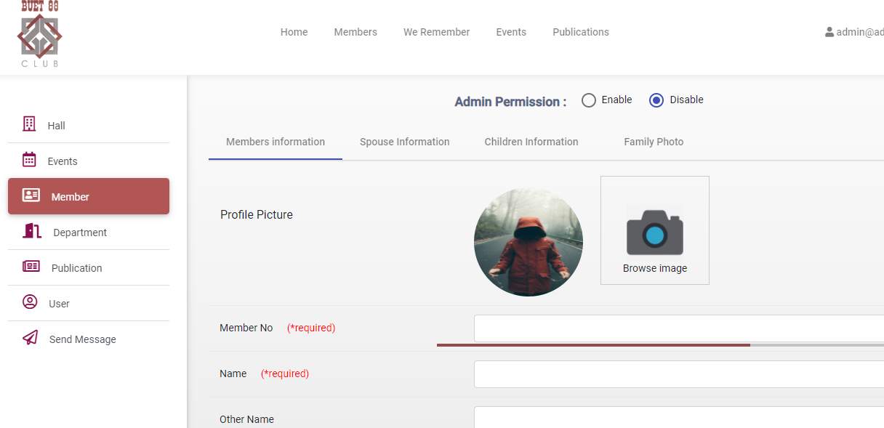

Figure 23: add member Form

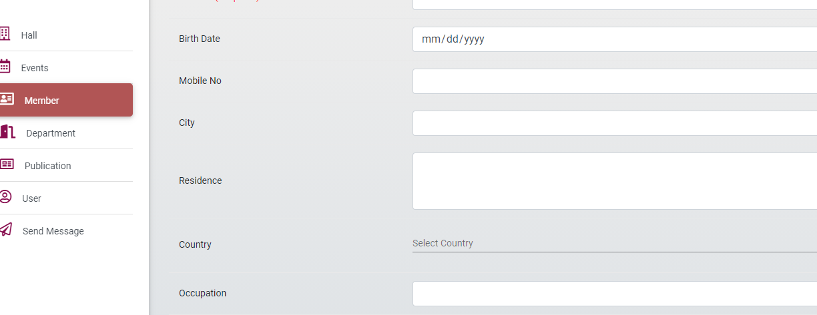

Figure 24: add member form

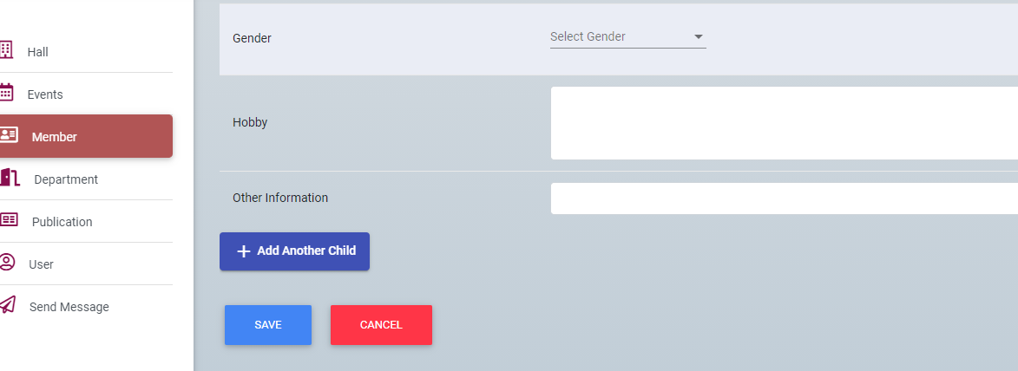

Figure 25: add children

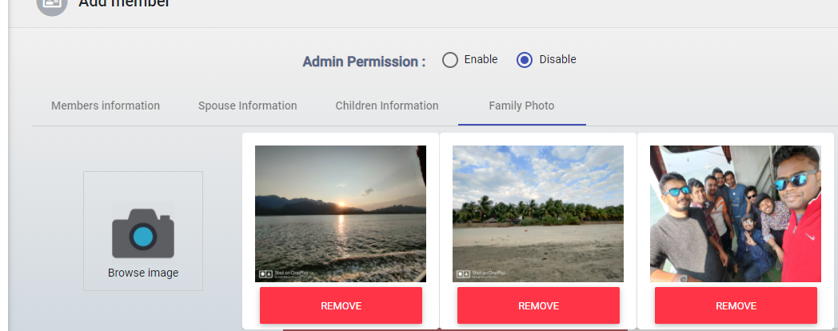

Figure 26: family photo upload

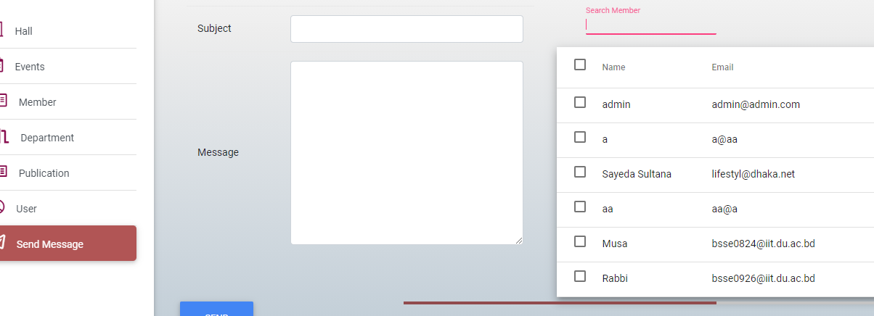

Figure 27: send message

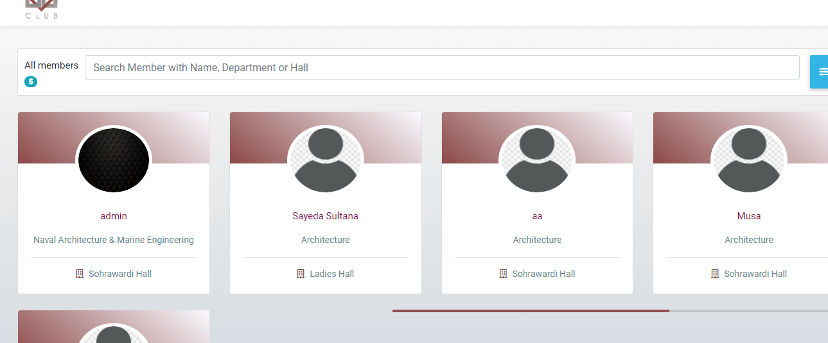

Figure 28: Member information

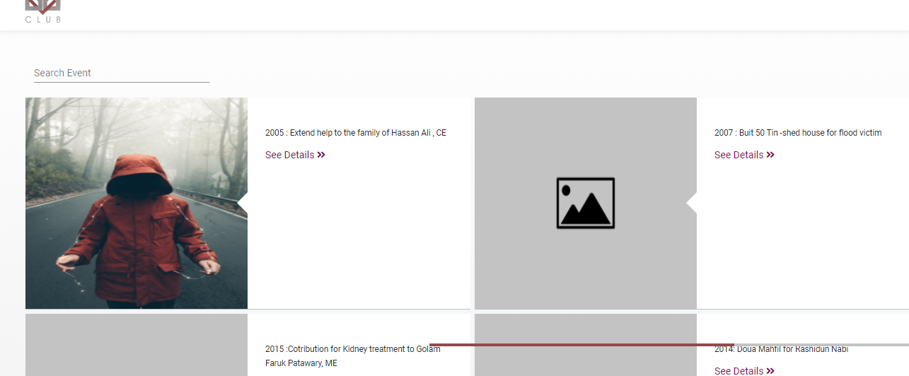

Figure 29: Event Show

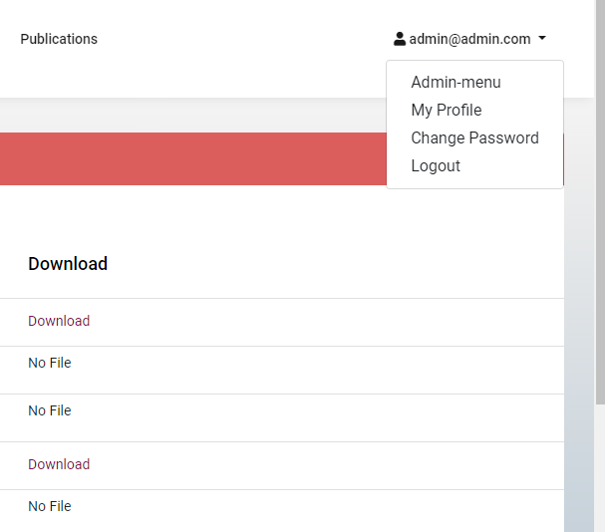

Figure 30: Authentication part

Chapter-5: My project Involvement and Contribution

# 5.1 Overview

I have Streams Tech in January. After Joining our Supervisor give us resources to learn for future work. I learned Angular, ASP.NET and so on using these resources, YouTube and google.

In February, we started develop a project using these. Actually, my teammate was other interns. Throughout my internship period I was fully assigned to a wonderful, challenging and long-term project named Select Network. The project currently works on its 1st version. The following part of this chapter I describe these phases separately.

# 5.2 Working Period

I have assigned in a team in February and worked at the end of my internship. I have worked successfully in my team.

# 5.3 My Contribution

I have contributed to the project mostly in developing. As we have need to test task before it moves to QA, I have implemented some features, improve existing one and mostly fixing bugs. In below I have discussed shortly some of my works.

• Develop a material table for crud.

• Create a form for add title, description and image for admin panel

• Developed fully admin panel in stl_showcase project

• Listing for showing tables for hall, departments, members, users etc.

• Develop Add, Delete, Edit form for this feature.

• Uniqueness check for this feature form.

• Mat tab used for more feature.

• Form Array used for re using the component.

• User permission for admin purpose and so on.

# 

# 5.4 Challenges

Since these projects was developed for customer so we have followed agile development methodology. So, I have faced many challenges to perform my assigned tasks.

• Working as a frontend developer, debugging code and analyzing bugs were difficult.

• To support responsive behavior in many devices.

• Evolving requirement engineering, implement new features, improvement and bug fixing of existing features with time constraint and deadline was so much difficult.

• Maintaining SourceTree was difficult.

Chapter 6: Acquired Skill

# 6.1 Overview

I have learned many software development process like waterfall model, agile model and many more in IIT. In industry this approach doesn’t work now because of changing requirements from client. I acquired skill in various tools and technologies as well as soft skills.

# 6.2 Professional growth

In all Streams Tech project agile process is being used. However, I had little bookish knowledge on agile development process. As I mentioned earlier Streams Tech follows rapid agile development process, my team also follow the process. Everyday morning there is a scrum meeting where previous day update is provided and current day tasks are discussed. It helps all team member to up-to-date with all others works. Since the scope of the projects is huge and everyone works in different module, it is difficult to anyone to know everything of the projects. So, knowledge sharing sessions are arranged to discussion the problem and its approximate solution among the team members. Following are the list of skills which I acquired as my professional growth in my internship program.

## 6.2.1 How to communicate

Everyone knows how to communicate with each other. But as a member of professional team, you need to know how to communicate appropriately, how to communicate with the seniors in the office. During the time of internship, I learned how to communicate professionally

## 6.2.2 Stop fingering points

Software development is always a group or team work. And in a team, there are various types of persons with different mentality. Misunderstanding will happen. Sometimes it happens it Streams Tech. But it really doesn’t create any unexpected situation. Everybody handles these situations very well. And nobody blames another for any kind of fault done in the project. Everybody is aware of their responsibilities.

## 

## 6.2.3 Punctuality

When I was in IIT, I was punctual enough. I was often late in the class. But in Streams Tech, I saw every employee was punctual. I was inspired by this and started to develop this virtue in me.

## 6.2.4 Appraisal of Work

In Streams Tech the project manager is very proactive in approach. They know how to make the best use of their resource. They know very well that bullying can’t increase productivity and thus they never bully. But when people carry out their work perfectly, they praise them. Appraisal is something that motivates the employees to work more efficiently.

## 6.2.5 Co-operative

During my internship I have troubled with numerous problems where I didn’t find any way out and I needed someone experienced who can help me. As a surprise for mine, I have found every time a person who helped me out. I have also seen that help from the colleagues are required by most of the employees. I am amused to see the helping attitude of everyone. Most of the time they try to help others with their best effort.

# 6.3 Technological growth

As I learned how many technologies in here all of them were new for me. So, May I say my technical growth is very high.

## 6.3.1 Tools and IDE

Following are the tools and technologies which I have learned in my internship period.

## 6.3.1.1 Visual Studio 2017

Visual Studio 2017 is an integrated development (IDE) from Microsoft. It has enriched features for developer to develop their products on top of .NET framework. I have worked with Visual Studio while working with team to develop ASP.NET MVC application.

## 6.3.1.2 Visual studio Code

Visual Studio Code is a free source-code editor made by Microsoft for Windows, Linux and macOS. Features include support for debugging, syntax highlighting, intelligent code completion, snippets, code refactoring, and embedded Git.

Users can change the theme, keyboard shortcuts, preferences, and install extensions that add additional functionality.

## 6.3.1.3 JetBrains ReSharper

ReSharper makes Visual Studio a much better IDE ReSharper extends Visual Studio with over 2200 on-the-fly code inspections for C#, VB.NET, ASP.NET, JavaScript, Typescript and other technologies. For most inspections, ReSharper provides quick-fixes (light bulbs) to improve the code.

## 6.3.1.4 Microsoft SQL Server Management Studio 2017

SQL Server Management Studio (SSMS) is an integrated environment for managing any SQL infrastructure, from SQL Server to Azure SQL Database. SSMS provides tools to configure, monitor, and administer instances of SQL Server and databases. I use SSMS for managing database for all of my .NET projects.

## 6.3.1.5 PostgreSQL

It is a free and open-source relational database management system (RDBMS) emphasizing extensibility and SQL compliance. It was originally named POSTGRES, referring to its origins as a successor to the Ingres database developed at the University of California, Berkeley. In 1996, the project was renamed to PostgreSQL to reflect its support for SQL. After a review in 2007, the development team decided to keep the name PostgreSQL and the alias Postgres.

## 6.3.1.6 Postman

Postman makes API development faster, easier, and better. The free app is used by more than 3.5 million developers and 30,000 companies worldwide. Postman is designed with the developer in mind, and packed with features and options. I use postman for testing my controller action is worked properly or not in .net project Postman features include:

✓ Powerful, simple to use GUI

✓ Saved history of API requests

✓ Unlimited collections, environments, tests, and sharing

✓ Automated testing with collection runner

✓ Web-viewable, detailed API documentation

✓ Flexible API monitoring, for uptime, performance, and accuracy

✓ Mock servers, to support split-stack development.

## 6.3.1.7 SourceTree

A Git GUI that offers a visual representation of your repositories. SourceTree is a free Git client for Windows and Mac. SourceTree for Windows simplifies how you interact with Git repositories so you can focus on coding.

**Get your team up and running** using common Git commands from a simple user interface

**Manage all your Git repositories**, hosted or local, through a single client

**Put Git commands at your fingertips:** commit, push, pull and merge with just one-click

**Use advanced features**such as patch handling, rebase, shelve and cherry picking

**Connect to your repositories** in Bitbucket, Stash, Microsoft TFS or GitHub.

## 6.3.2 Language and Framework

I have learned new languages and framework for my project purpose. Description of each languages and framework given below

## 6.3.2.1 Language

**C#**

C# is a simple, modern, general-purpose, object-oriented programming language developed by Microsoft within its .NET initiative led by Anders Hejlsberg. C# is an elegant and type-safe object-oriented language that enables developers to build a variety of secure and robust applications that run on the .NET Framework. We can use C# to create Windows client applications, XML Web services, distributed components, client-server applications, database applications, and much, much more. Visual C# provides an advanced code editor, convenient user interface designers, integrated debugger, and many other tools to make it easier to develop applications based on the C# language and the .NET Framework.

**Typescript**

Typescript is an open-source programming language developed and maintained by Microsoft. It is a strict syntactical superset of JavaScript and adds optional static typing to the language. Typescript is designed for development of large applications and transcompiles to JavaScript. As Typescript is a superset of JavaScript, existing JavaScript programs are also valid Typescript programs. Typescript may be used to develop JavaScript applications for both client-side and server-side execution (as with Node.js or Deno). There are multiple options available for transcompilation. Either the default Typescript Checker can be used, or the Babel compiler can be invoked to convert Typescript to JavaScript.

## 6.3.2.2 Framework

**ASP.NET Core**

ASP.NET Core is a new open source, cross platform framework to create modern Web based Cloud based systems, which means, now you are not only working for Windows, you can run in Linux, Mac; i.e., wherever you want. Feature of ASP.NET core is given below- 1. Cross platform, open source now runs your app over Linux, Windows, Mac. 2. Fast Development- fast work over the Browsers. 3. Work in your editors - now you can work not only in Visual Studio. You can also choose Visual Studio code and if you want to work on your command on the command prompt, then you can. ASP.NET Core was learned for understanding how asp.net is used in web application.

**ASP.NET MVC**

The Model-view-controller (MVC) is an architectural pattern framework developed by Microsoft which is an alternative to asp.net web forms for creating web application. The Asp.net MVC framework is a lightweight and testable framework with existing asp.net features such as master pages, authentication, etc. and it will split application into three components Model, view and controller. The central ideas behind MVC are code reusability and separation of concerns. The model consists of application data, business rules, logic, and functions. A view can be any output representation of data, such as a chart or a diagram. Multiple views of the same data are possible, such as a bar chart for management and a tabular view for accountants. The controller mediates input, converting it to commands forth model or view. Building application with MVC architecture helps developer to write more manageable code. For implementing web application, I have learned ASP.NET MVC.

**Entity Framework**

The Entity Framework provides three approaches to create an entity model and each one has their own pros and cons. They are Code First, Database First and Model First. I have learned

code first and Database first approach of entity framework. Entity Framework has a modeling workflow referred to as Code First & Database first.

1. Code First modeling workflow targets a database that doesn’t exist and Code First will create it. DB first create database model automatically generated code

2. It can also be used if you have an empty database and then Code First will add new tables to it.

3. Code First and DB first allows you to define your model using C# or VB.Net classes. Using entity framework code first approach I implemented some feature for learning purpose.

**Angular material**

Design component for Angular. It is Fast and consistent. It is versatile. It is optimized for Angular. I used this in my projects for design.

**MdBbootstrap**

It is a material design for Bootstrap. The world most popular framework for building responsible, mobile-first websites and apps. Last project we used mdbbootstrap Angular.

**Front End Framework (Angular)**

Angular is a structural framework for dynamic web apps. It lets you use HTML as your template language and lets you extend HTML's syntax to express your application's components clearly and succinctly. Angular data binding and dependency injection eliminate much of the code you would otherwise have to write. And it all happens within the browser, making it an ideal partner with any server technology. Angular is not a single piece in the overall puzzle of building the client-side of a web application. It handles all of the DOM and AJAX glue code you once wrote by hand and puts it in a well-defined structure. This makes Angular opinionated about how a CRUD (Create, Read, Update, and Delete) application should be built. But while it is opinionated, it also tries to make sure that its opinion is just a starting point you can easily change. It is cross platform.

# 6.4 Self-Assessment

In this section I try to represent my perspective and ideas about my achievements as an intern. Here I would assess my capabilities that I have achieved during my internship

program. Since an Evaluation Form has evaluated from my colleagues based on that and my supervisor opinion, I have measured my quality as below.

## 6.4.1 Attitude As an intern

I always try to maintain the positive attitudes to represent myself along with my institute. I am accustomed to concentrate on my assigned work. I refine myself from doing anything that may causes any reputation issues for me and my institute. I always remain friendly not only

with my teammates but also with others peoples. I give such effort to express my dedication for work and try to contribute to the company through this effort.

## 6.4.2 Ability to Learn In Streams Tech

I worked with very friendly and helpful mentors. They taught me really well and I was also able to catch their teaching. I think I was very adaptive to new technologies and I have learned those effectively.

6.4.3 Dependability

During the initial phase of my internship I was assigned to various experimental projects. I was able to complete them successfully; I could prove my dependability. And so, I was then assigned to more sophisticated projects. My supervisor let me do my task and evaluate my working capability after completing.

## 6.4.4 Quality of Work

The quality of work depends on both my previous study and what I have learned from this company. As I have done some of the important course at IIT such as software requirements and specification, design pattern, software testing, software design and analysis, it helps me doing clean code for meeting the requirement. They said that- I could do clean code, and from my point of view, the reason behind this was some effective courses of IIT.

6.4.5 Relationship with colleagues

‘Professionalism’, ‘Excellence’ and ‘Respect’ are mottos of IIT. I have learned many courses and with all of my heart I have followed these in last three years. I have always respect to my supervisor, teammates, and colleagues. In Streams Tech we all are treated as family so we call it Streams Tech family. I have taken part in hangout, team event, and iftar party with team, Falgun celebration and Pahela Baishakh which enable me to be close with all members. I hope this relationship will remain unchanged.

## 6.4.6 Maturity Poise

I have always been confident about myself. If I want to do something from my heart, I will succeed. And my confidence level has increased in these 5 months even more.

## 6.4.7 Judgment

In my team we are following agile process. Every sprint I take task and commit when I will finish the task. Besides that, I need to analysis the task and understand the business logic. Before implementing the task, I take decision in my work quality such as optimization, pattern and approach. However, my team lead allows me to share my opinion on any development approach which should be done or should not be done or another better way for implementing the task. All those reflect the ability of judgment.

## 6.4.8 Overall Performance

I think the points mentioned in the upper sections describe well about my overall performance. I was very much sincere, proactive, punctual, keen to learn, and self-driven. And that is why; I strongly believe that my performance during the internship period was outstanding.

Chapter 7: Conclusion

To complete my academic learning and before move towards the next level of my career the internship program was the most important part in my BSSE program. Journey to be a professional software engineer it never be so perfect without working in a renowned software company like Streams Tech. The internship program made me accustomed to the professional company culture and the technologies they mostly deal with. Throughout my internship it has helped me to develop professionalism, patience, good judgment and made me so strong to face new problems, challenges which has helped me to develop better analytical skills also. The projects in which I worked inspired me to be confident, responsible and helped me with all means to build a research mind, motivate to works, enjoying my works.

The internship program has been a great helping the sense that it improved my team work capabilities. At the companies it is important to function as a unit and respect the team mate’s ideas and suggestions. Team discussions like brain storming sessions helped me identify and solve numerous problem issues which would have been impossible to solve otherwise.

I would like to convey my thanks to Institute of Information Technology for providing me an opportunity to gain idea of the competitive environment in the professional field. It has certainly lifted my software development skills in terms of design and coding. Now I look forward to facing the upcoming challenges of the world.

References

1. <https://www.streamstech.com.bd/> Last accessed 03 July,2020
2. <http://showcase.streamstech.com/#fusion-scroll-section-element-1-3> Last accessed 05 July,2020
3. <https://angular.io/> Last accessed 01 July,2020
4. <https://material.angular.io/> Last accessed 01 July,2020
5. <https://www.linkedin.com/company/streamstech/> Last accessed 07 July,2020
6. <https://en.wikipedia.org/wiki/PostgreSQL/> Last accessed 06 July,2020
7. <http://buet88club.streamstech.com/#/> Last accessed 07 July,2020
8. <https://www.w3schools.com/cs/> Last accessed 06 July,2020
9. <https://visualstudio.microsoft.com/> Last accessed 08 July,2020
10. <https://www.typescriptlang.org/> Last accessed 10 July,2020
11. <https://www.sourcetreeapp.com/> Last accessed 03 July,2020
12. <https://www.tutorialsteacher.com/core> Last accessed 10 July,2020
13. <https://www.microsoft.com/en-us/sql-server/sql-server-2019> Last accessed 11 July,2020
14. <https://www.jetbrains.com/resharper/> Last accessed 07 July,2020
15. <https://mdbootstrap.com/> Last accessed 08 July,2020